Salesforce Workflow
Contents
Quick Reference - Links to All Video Resources/Walkthroughs 2
First Login & Multi-Factor Authentication 2
Intake for a New TFC Household 3
Intake for Family Previously Served by TFC 5
New Intake for a family in Salesforce but not enrolled in TFC 5
View All Cases Assigned to Me as a Care Team Member 6
Income Update 6
Six-Month Updates 6
Add New Household Member to TFC Enrollment 6
Remove Household Member from TFC Household 6
Employment Update (New Employment, End of Employment) 7
Client Goals 7
Education Updates 7
Housing Prevention 7
Housing Placement 8
Financial Assistance 8
Session Log 8
Log General Case Note 9
Referrals 9
Managing Enrollments for Coaching & Wraparounds (Partner Agency Enrollments) 9
Dashboards 10
HMIS Project Details 10
Events 11
Exit Information 12
Data Syncing (Data Bridge) 12
Duplicate Households 13
Troubleshooting 13
Communication Protocol 14

This guide applies to The Family Collective Salesforce App released in June 2021.

Quick Reference - Links to All Video Resources/Walkthroughs
- TFC Database Overview Training (6/15/2021)
- New Intake
- Income Update
- Employment Updates
- Client Goals
- Housing Preventions or Placements
- Session Log
- TFC Exit Information

First Login & Multi-Factor Authentication
Salesforce requires users to use Multi-Factor Authentication for security. You will need to set this up the first time you access Salesforce. (Login at https://login.salesforce.com)
- On your phone: Download and install Salesforce Authenticator for iOS from the App Store or Salesforce Authenticator for Android from Google Play.
- Tap the app icon below to open Salesforce Authenticator. (You may have multiple Authenticators on your phone. Make sure it is the one with this icon.)
- On your computer: Login to Salesforce from https://login.salesforce.com/. If you have never logged in before, use the link you received to set up an account.
- You will be prompted to Connect Salesforce Authenticator.
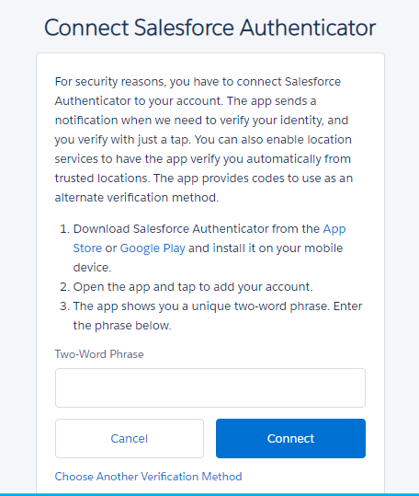
- On your phone: Enter your mobile number to create a backup of the accounts that are connected to Salesforce Authenticator. Then tap the notification when prompted to complete the verification. Create a passcode, if needed.
- Click “Add an Account” to add your Salesforce account. You will be given a two-word phrase. Enter that phrase on your computer.
- On your computer: Click “Connect.”
- On your phone: Click “Connect.”
- Every time you login to Salesforce, you will get a notification on your phone. Open up the Salesforce Authenticator app, click “Approve,” and finish logging in. You can also set up your phone to automatically approve logins when you are in a certain location (like your home or your office) if you feel comfortable doing so.

Intake for a New TFC Household
- New Intake Video

Note: As you are navigating through the Intake form, you must press blue buttons for “Save,” “Add Household Member,” etc. as you go. For example, on the Client Details tab, you must press Save for every household member. These blue buttons trigger the form to create records in the database.

- Before you begin If anyone in Household works and receives employment income, you may need to add a new Employer record for them, if the employer is not already in the system:
  - Click the Down Arrow beside Accounts and then click New Account.
  - Click Employer and then Next.
  - Add the Name and other details if you have them (contact info, etc.) for the Employer.
Eligibility Tab
- Click Intake Form
- Enter the Number of Adults and Children under Household Size
- Enter whether anyone in family is pregnant
- Enter the Head of Household and any Household member who receives income in the next section. (You can skip family members who have no income for now.)
- Click Add Wage and fill in employment and wage information for any household member who is working. (You will use the Employer record you created in step 1.)
- Enter any other cash income and benefits. Enter “0” for benefits that the household is not receiving.
- Click Add Household Member.
- Review FPL calculation for eligibility. If family is over 185%, answer questions regarding homelessness status.
- If TFC Eligibility status shows a green box saying “Eligible,” click Save and Enroll in TFC to continue.
Client Details Tab
- Enter Demographic and Contact info for first household member. (Names and birthdates for family members that were entered in Eligibility tab will be transferred.)
- If household is not in HMIS, you may check “Client doesn’t know SSN” and leave SSN blank.
- Enter pregnancy status, criminal background, and eviction history.
- Click Save.
- Repeat steps 11-14 for additional household members. Press Save after adding each household member.
- Under Enter Household Information, enter Living Situation at Entry, Address, and Emergency Contact info.
- On the right of the page, there is a place to upload Files. If you have a Release of Information (ROI) for this household, you can upload it now. (You can also upload it later on the main household Program Engagement page.)
- Enter whether you have received verbal permission, collected, or uploaded a Salesforce ROI.
- Complete other ROIs if needed.
Income and Benefits Tab
- Any Cash Income you reported in the Eligibility Tab will carry over to this screen. Indicate whether each amount is verified. Make any other changes needed.
- Enter any Non-Cash Income.
- Click Save.
- Click Continue.
Education Tab
- Enter highest education completed and any current education enrollments for all adult household members.
- If needed, enter estimates for enrollment and completion dates.
- After entering one education record, click “Add Education Record.”
- Then, you can enter any additional information needed for other adult household members.
Assessments Tab
- Enter responses for initial TFC Self Report.
- Click Save.
- Switch tab at top to Arizona Self Sufficiency.
- Enter responses for initial ASSM.
- Click Save.
- Click Continue.
Partner Agency Enrollment Tab
- Enter the name of your Agency.
- Enter the name of the Program Coach for this enrollment.
- If you know that another care team member (housing specialist, etc.) is currently serving this household, you may add them here.
- Enter enrollments for Employment Navigator and Housing Specialist only if/when the family has been referred to these services (housing or employment). This might be at enrollment, but it might be once the family is introduced/connected to the service provider.
Restarting/Continuing Intake Form
NOTE: If you cannot complete any part of the Intake form, you can pause and then return. To do so, navigate away from Intake form. When you are ready to complete, search for the household’s Program Engagement record using the top search bar. (The Program Engagement record will be named “HOH Last Name (HOH First Name) Household: Enrollment Date.”) Open that PE record and then click the Intake button at the top.

Intake for Family Previously Served by TFC
- Go to the family’s most recent Program Engagement Household record. (You can search for their name in the search box at the top of Salesforce.)
- Click Intake at the top of the record.
- The system will take you to the Intake screen and pre-populate any information from the most recent time that the family worked with TFC. Make any updates in the Intake form, following steps above, to create a new TFC Household Program Engagement and begin serving household again.

New Intake for a family in Salesforce but not enrolled in TFC
- Your agency may enter families (Accounts & Contacts) in Salesforce that are not served by TFC (as a volunteer, participant in another program, etc.).
- To create a TFC Intake for one of these families, open up the family’s Account. This is a record that generally looks like “[Last Name] Account]”.
- At the top right, click the button New TFC Intake.
- This will create a new TFC Intake for the family and automatically populate basic information already in Salesforce (name, DOB, etc.).

View All Cases Assigned to Me as a Care Team Member
- Click on Partner Agency Enrollments along the top of the screen.
- Click the down arrow beside Recently Viewed.
- Choose either My Households or My Open Households.
- You may want to click the Pin beside the name of the view (My Households or My Open Households) to make this your default view.

Income Update
- Income Update Video

- Income is tracked per household member. From a household Program Engagement record, you can see the list of household members at the top under Program Engagement (Participants). Click on the Program Engagement name of the individual whose income you want to update (e.g. Doe (John) Participant: 2021-06-04).
- If there is no previous Income record, you can click New and create a New one.
- If the person works, open up the Income record you just created and click the down arrow beside Wage Details and then click New.
- If there is a previous income record that you are updating, open up the most recent Income record for this family member. Click Create Income Update button at the top of the screen. Follow instructions to update income.

Six-Month Updates
- If you are a coach assigned to TFC cases, you will be signed up for a weekly report that lists any of your households that are due for a 6 month update.
- When you receive this email, please review any case(s) due for update.
- Please complete a TFC Self Report and ASSM.
- Please update any other information as needed, such as employment status, living situation, contact information, etc.

Add New Household Member to TFC Enrollment
- If a new member is added to a TFC household (baby born, family member moved into household), go to the family’s Household Program Engagement.
- Click the Add Family Member button in the top right of the screen, and follow instructions to add a new family member.

Remove Household Member from TFC Household
- If you are creating a new enrollment from a previous household where one of the household members is no longer in the household, go to the person’s Contact record. You can use the search bar at the top to find this.
- Under Current member of household, change the value to “No.”
- Go to the household’s most recent Household Program Engagement record. Use the Intake button at the top to start a new Intake. The family member you just removed will not be included in the household.
- If a family member leaves the program in the middle of an active engagement with TFC, contact John to address because it may require deleting or moving existing records.

Employment Update (New Employment, End of Employment)
- Employment Updates Video

- Employment is tracked per household member. From a household Program Engagement record, you can see the list of household members at the top under Program Engagement (Participants). Click on the Program Engagement name of the individual whose income you want to update (e.g. Doe (John) Participant: 2021-06-04).
- Scroll down to Employment Details. Click New.
- Fill in information about employment and click Save.
  - If the Employer is not already a record in the system, you can click into the Employer field, then click “New Account.” Then choose “Employer,” click Next, and enter information about the Employer. Click Save and then go back to the Employment Details record and finish.

Client Goals
- Client Goals Video

- From Program Engagement Household, scroll down to Client Goals. Click New.
- Enter goal information
  - Begin with Domain. Move to Outcome and Specific Goal/Action Steps.
  - Specific contacts in the family can be linked to the goal if needed
- Click “Save” (if entering a single goal) or “Save and New” (if entering multiple goals for household)

Education Updates
- Education is tracked per adult household member. From a household Program Engagement record, you can see the list of household members at the top under Program Engagement (Participants). Click on the Program Engagement name of the individual whose income you want to update (e.g. Doe (John) Participant: 2021-06-04).
- Scroll down to Education History.
- Click New and enter information about the education enrollment.
- Click Save.

Housing Prevention
- Housing Preventions or Placements Video
Housing Prevention - family stays housed in own housing
- From Program Engagement Household screen, scroll to Service Deliveries and click New.
- Select Housing Prevention.
- Click Next.
- Enter information about the housing prevention service (date of prevention, etc.).

Housing Placement
- Housing Preventions or Placements Video
Housing Placement - family moves into new appropriate housing, with or without assistance from TFC in identifying unit
- From Program Engagement Household screen, scroll to Service Deliveries and click New.
- Select Housing placement.
- Click Next.
- Enter information about the housing placement service (date of placement, etc.).
- Back on the main Program Engagement Household page, click the name of the household (e.g. “Doe Household”) under “Household Account” along the top of the record.
- Scroll down and click the pencil beside Address to edit the family’s address.
- Click Save.

Financial Assistance
This is to track financial assistance offered to families. It was previously known as Client Assistance or Grant Expenses.
- On the main Program Engagement Household page, scroll down to Financial Assistances.
- Click New.
Alternately, you can go to an existing Service Delivery record, such as a Housing Placement. Open up that record, click Related and then click New beside Financial Assistances.
- Enter any information about the Financial Assistance, such as the Category, Assistance Type, Amount, and Date Paid.
- Grant line item will be in the format “DHS – FY 20/21 – Agency Line Item Description.”
- Under Program Information, you can enter a Service Delivery (such as a Housing Placement or Housing Prevention) that is related to the expense.
- You can also enter the Household in the Household field.
- Click Save.

Session Log
- Session Log Video
(Sessions include meetings scheduled, in person, or long conversations on the phone/Zoom, to help other members of Care Team know the status of client and goals. These are substantive sharing of information, goal-setting, etc.)
- From Program Engagement Household screen, click “new” in Service Deliveries box
- Choose “Session.” Click Next.
- Enter Session information, including case note if the session is “completed”. The case note will automatically populate in the case note section.
- Click “Save” (if entering a single session) or “Save and New” (if entering multiple sessions for a household).

Log General Case Note
- Session Log Video [Case Notes at end]
(General note about client e.g., brief communication to set up a meeting time for a session, etc.)
- From Program Engagement Household screen, go to Case Notes. Click New.
- Enter any information in the case note and click Save.
- Case notes related to specific goals or session logs should only be entered from those screens.

Referrals
At this time, we unfortunately do not have a way to do referrals directly in Salesforce, such as generating an automatic email to the referral partner. (This is a feature we are working on for next release.) Please use case notes and coordinate with other care team members via email/phone. Remember there is a TFC contact list.

Managing Enrollments for Coaching & Wraparounds (Partner Agency Enrollments)
During a TFC Intake, a Partner Agency Enrollment record should be completed for the household that lists the open date, agency, and coach for that household.
When a household is referred to another agency, either for coaching or wraparound services, the care team member(s) at that agency should add a Partner Agency Enrollment listing their agency’s services.
To enter a new Enrollment when services start:
1. Go to the family’s Program Engagement (Household) record.
2. Scroll to Partner Agency Enrollments.
3. Click New.
4. Enter the Agency, care team member(s) in appropriate fields, and start date for that service (not for the family’s engagement with TFC as a whole).
5. Click Save.
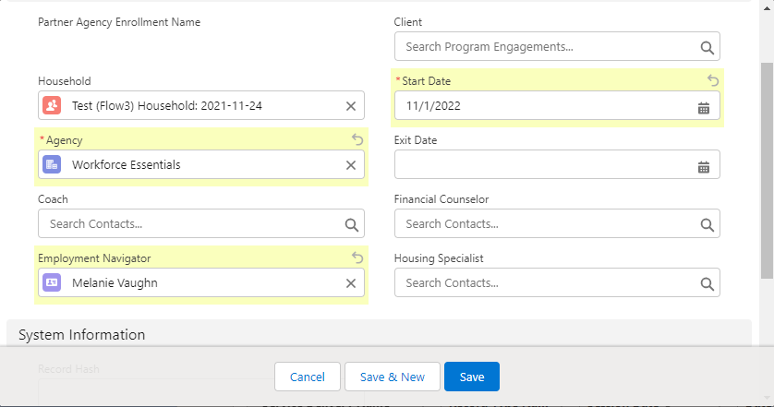

When this enrollment ends:
1. Go to the family’s Program Engagement (Household) record.
2. Scroll to Partner Agency Enrollments.
3. Open the Partner Agency Enrollment record for your agency.
4. Enter a close date.
5. Click Save.
Note: This assumes that the family is still enrolled in TFC overall and just is closing out of services from a particular wraparound agency. If the family is exiting from all TFC, the coach should complete an exit (see “Exit Information”) and exit the Enrollment for any wraparounds that are still open.

Dashboards
- On any page in the TFC App, click the Dashboards tab along the top of the page. (If for some reason you don’t see it, you can also click the App Launcher () and then type in Dashboards.
- Click All Dashboards along the left.
- Click Coaching Dashboard.
- This will take you to an updated version of the dashboard that was called Case Manager Dashboard in the old Salesforce.

HMIS Project Details
- HMIS Project Details video
HMIS Project Details are records you can use to track data that is related to enrollment into an HMIS project. As of 11/17/2022, we are testing exporting data from TFC partners and importing directly into Davidson County HMIS.
To create new HMIS Project Detail records from the main Household Program Engagement page:
- Scroll down to HMIS Project Details.
- Click New
- Choose HMIS Project Detail (HOH).
- Enter basic information, including the Active Project, Start Date, Living Situation at Entry, and any information that you want to be carried over to all household members (such as Health Insurance, if that is shared amongst household members).
- Click Save
- The system will generate HMIS Project Detail records for all family members with the basic information you entered.
- Now make any updates related to individual household members. For example, add any household member’s disability status.
- If a household is enrolled in multiple HMIS projects, follow the same process for the additional HMIS projects.
When a household is housed, exits an HMIS project, or has some other update (new living situation, etc.), make updates to the HMIS project detail record as needed.

Events
- On any page in the TFC App, click the App Launcher () and then type in Events and click on it.
- Click New.
- Enter any information about your event (number of attendees, etc.). Click Save.
- After the record is saved, you can also attach files, such as photos.

If you want to log attendance at an event by a family that is in the system, go the family’s Program Engagement Household record.
- Click on New beside Service Deliveries.
- Choose Event.
- Enter a name for this record in Service Delivery (e.g. “attendance at 2021-06-28 book club”). Search for the Event that the household attended in the Event field. Click Save.

Exit Information
- TFC Exit Information Video

- On the Program Engagement Household page, scroll to Assessments.
- Click New. Choose TFC Self Assessment.
- Complete TFC Self Report fields. Choose Exit as Assessment Time Point.
- Note: If you are unable to complete (lost contact with family, etc.), choose Unable to Complete on Assessment Status field.
- Follow the same steps to complete an ASSM with Exit time point.
- Go back to the main Program Engagement Household page. Scroll down to Program Exit. Click the pencil beside Subsidy at Exit and Closure Reason to complete these fields.
- Scroll up to Partner Agency Enrollments. Click on the Partner Agency Enrollment that is currently open. Click Edit.
- Enter an Exit Date. Update any other information if needed.
Make sure all information in SF is updated before exiting (income, disability information, health insurance, housing status, employment status, logged final case notes and all sessions, etc.)

Data Syncing (Data Bridge)
As of 11/17/2022, all agencies except for Catholic Charities and Safe Haven Family Shelter are sharing data with other TFC agencies via a “data bridge.” This means that agencies should be able to see other agencies’ notes and records related to their TFC families. Data is synced every 2 hours or so during the week and a couple of times during the weekend, so it is not quite real-time.
All information related to households through the TFC Intake Form will be synced with other TFC agencies. (Please be sure to get a Release of Information completed for all families.)
Accounts and Contacts that are entered separate from the TFC Intake Form (such as Employers, Landlords, etc.) can be synced if you check the “TFC Sync” checkbox and choose “Yes” for the “TFC Agreement” field on that Account. This ensures that only Accounts and Contacts related to TFC are shared with the rest of the TFC partners.
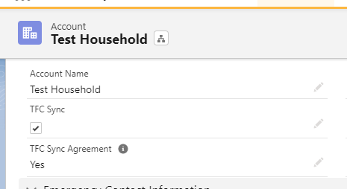

Duplicate Households
Due to the delays in getting sync operational, there are some duplicate records and other issues are being addressed. If you notice that a household does not have the case notes or other related information you are expecting, search for the household’s name, then look at Program Engagements in the search results. You might have more than one open Program Engagement (Household) for them. These records will eventually be merged, but for now you can go between them to see the various notes from each agency.
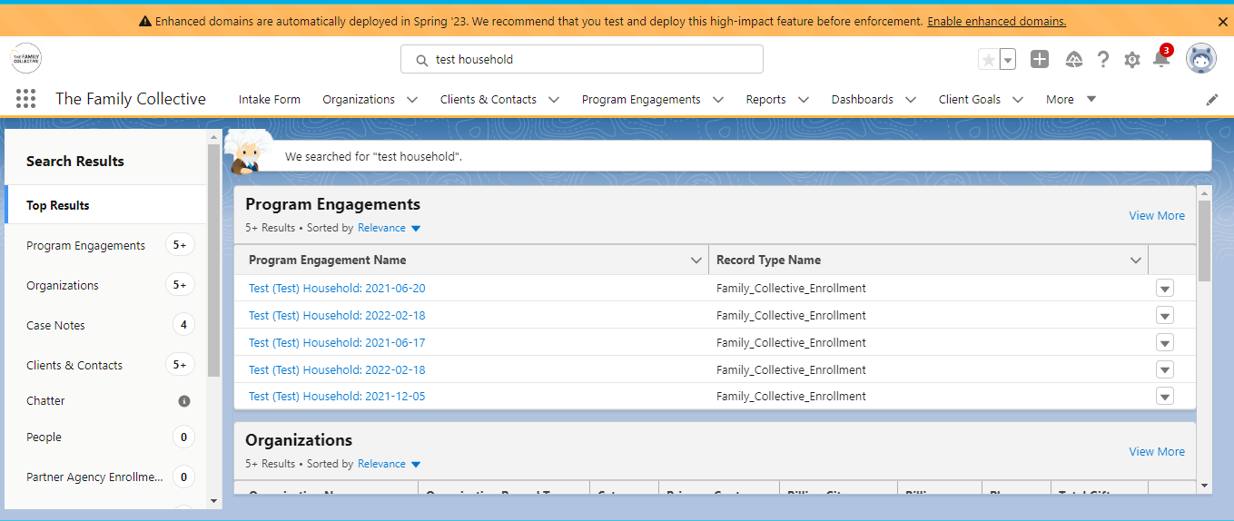

Troubleshooting
- If you forget your password…click “Forget your password” from the Salesforce Login screen (login.salesforce.com)
- If you get lost in Salesforce…click the “Program Engagements” tab, click on the “LastName (FirstName) Household” Program Engagement record you want to enter information for, or search for the last name of the client.
- If the screen seems frozen or you’re not sure your changes were saved, just refresh the page.
- If a Program Engagement says “Anonymous Household” instead of the name of the contact/household, make sure that the “Client” and “Household Account” fields on the left of the Household Program Engagement page are completed. The Household page should have the head of household listed in the “Client” field.
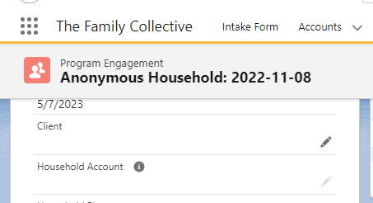

Communication Protocol
- For questions about eligibility and documentation needed for families, please speak to your direct supervisor at your organization
- For questions about training for staff, programmatic implementation questions, and anything related to family care, please contact nicole.piispanen@unitedwaygn.org.
- For questions about partnerships, budgetary issues, or collective impact framework, please contact rod.devore@unitedwaygn.org.

