2026 Workplace Campaign Toolkit
Donor Engagement and Email Templates
Email header options:
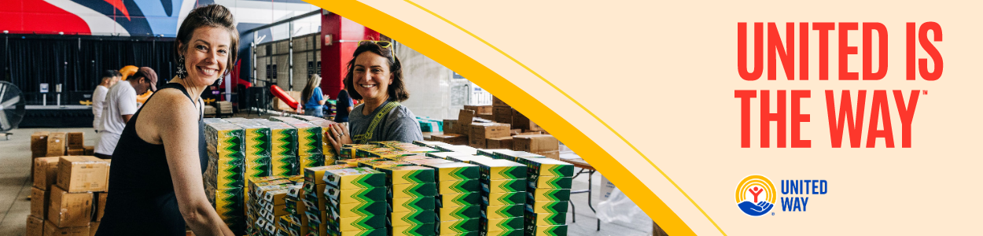
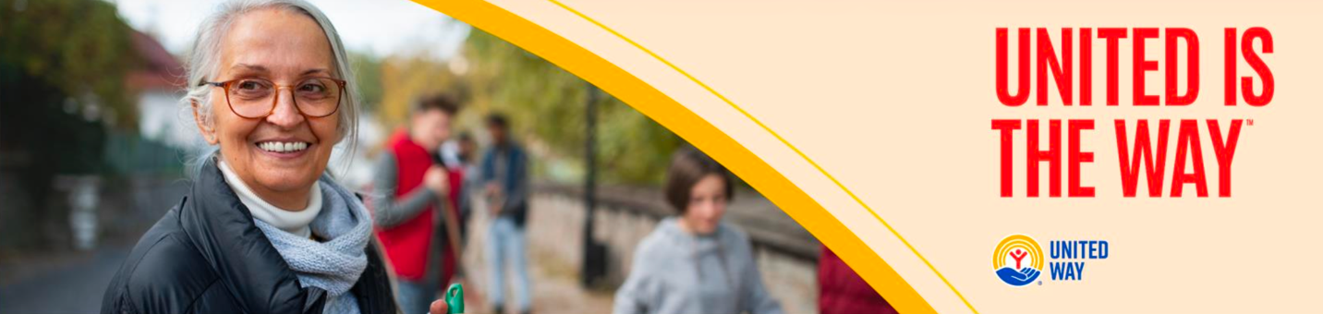
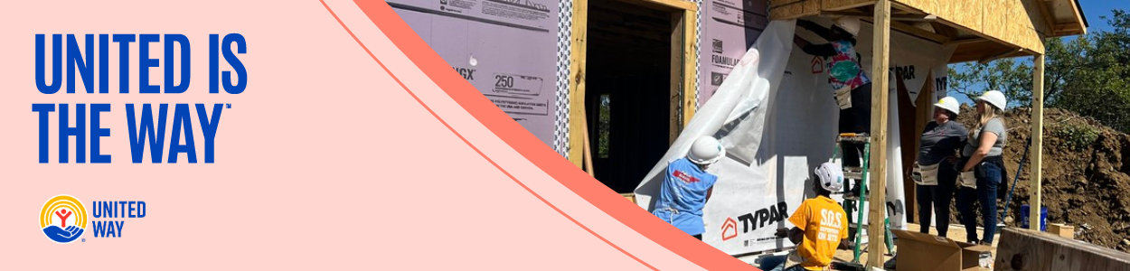
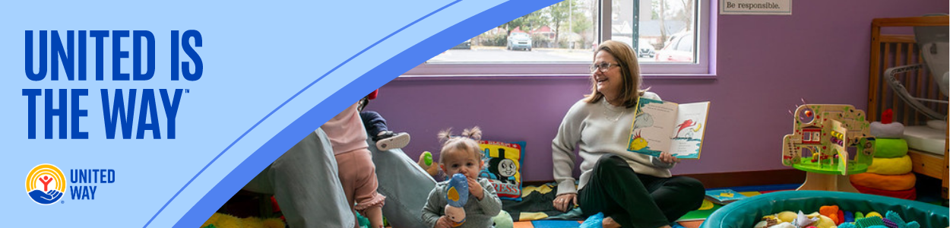

General Tips for Effective Donor Engagement
- Send From a Person, Not an Institution: When you send an email “from” a person rather than your organization’s name, it increases donor trust, confidence, and engagement.
- Subject Line: This is your first impression! Keep it short (under 50 characters), intriguing, and relevant to your cause. Consider a question, a local reference, or a sense of urgency that will resonate with your audience.
- Personalize: If possible, address your donors by their name. Segmentation tools in your email platform can help tailor your email messages as appropriate.
- Highlight Local Impact: Showcase how you benefit the community by using local success stories, statistics, references, and/or quotes from your community members.
- Include a Clear Call to Action: Clearly state your call to action and make it easy for the recipient of your email message to complete that action.
- Send Reminder Emails: Keep a steady drumbeat of support for your campaign by sending reminder emails when appropriate. Depending on the length of your campaign, we recommend sending one reminder email per week.

Recommended Donor Email Campaign Cadence

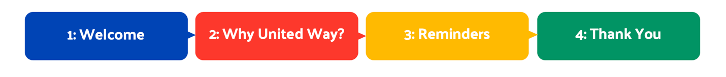

Phase 1: Welcome

Email 1a: Campaign Kick-off from United Way
From: Your United Way CEO/CPO, Board or Campaign Chair’s first and last name
Audience: All company employees
Subject Line: United is the Way to change lives in Greater Nashville
Email Body:
Today, so many of our neighbors are working hard to overcome barriers and get ahead. They are considered ALICE. ALICE stands for Asset Limited, Income Constrained, Employed — a group of hard-working individuals and families across Tennessee who, despite being employed and earning above the poverty line, still struggle with affording basic needs like transportation, housing, food, healthcare, and childcare.

Want to learn more? Affording Basic Needs: Shedding Light on our Working, yet Struggling Neighbors

Somewhere in our community:
A working parent is looking for a way to make this week’s paycheck cover the growing costs of groceries, prescriptions, and housing.
A middle-schooler is struggling to find a way to stay focused in class because she didn’t get a nutritious breakfast this morning.
A high school graduate is searching for a way to turn his diploma into a good-paying job and a promising career.
But they’re not alone.
Together with our community-serving partners and supporters like you, we can connect people to the opportunities they need to reach their full potential and make Greater Nashville a place where everyone can thrive.
Donate today and join us in creating more thriving communities for all. No challenge is too big for us to take on if we work together.
Because, United is the Way™.
BUTTON TEXT: Give Today [Hyperlink to donation page]
Sincerely,

Email 1b: Company CEO Welcome
From: Company CEO, Leader, or Employee Campaign Chair’s first and last name
Audience: All company employees
Subject Line: [COMPANY NAME] Team, please join me in supporting our neighbors in our community
Email Body:
At [COMPANY NAME], we believe in giving back to the communities where we live and work. That’s why I’m proud to support our friends at United Way of Greater Nashville– and I’m inviting you to join me.
Every day, United Way – with the support of community-minded partners, volunteers, and donors like us – is working hard to ensure that everyone has access to essential services and resources they need to thrive, including:
- Nutritious food and quality health care our neighbors need to lead healthy lives.
- Childcare, early learning, education, and enrichment to set kids up for success from cradle to career.
- Counseling, career training, and housing support to help families not only make ends meet but create a sustainable financial future.
- Emergency preparedness and disaster recovery efforts to ensure that our community stays connected, strong, and resilient, no matter what challenges we may face.
Please consider making a one-time or recurring gift to support this powerful work and send a message of compassion to our neighbors most in need. Together, we can make a transformative impact in our community.
United is the Way™.
[Insert information about how they can donate]
BUTTON TEXT: Give Today [Hyperlink to donation page]
Thank you in advance for your generous support.
Sincerely,

Phase 2: Why United Way?

Email 2: Our Value-Add
From: Your United Way CEO/CPO, Board or Campaign Chair’s first and last name
Audience: All company employees
Subject Line: What makes change in Greater Nashville possible? People like you!
Email Body:
For over 100 years, United Way of Greater Nashville has focused on harnessing the caring power of our community to help ensure that everyone can thrive. While the needs in [ANYTOWN] are great, and the challenges are sometimes daunting, we at United Way have the privilege of seeing the very best that our community is capable of.
There’s nothing more powerful than a group of people united to do good. Last year alone, with the help of partners, volunteers, and donors like you, United Way of Greater Nashville, was able to:
- Make 62,853 referrals through its 211 help line
- Increase literacy proficiency for 56,319 students
- Support 1,206 residents with dedicated financial counseling services, resulting in $1.5 million in total increased savings
- Serve 50,481 children through Imagination Library, distributing 510,768 books to homes
- Save millions in tax refunds by helping 6,573 families collect federal tax refunds through the free tax preparation program
And we’re not stopping there. Your support can help us continue addressing the biggest problems in our community. No challenge is too big for us to take on if we work together. Because when people unite to take action, transformational change is possible.
United is the Way™.
Give today and join us in creating more thriving communities for all.
To see United Way of Greater Nashville’s full impact last year, read the annual impact report.
BUTTON TEXT: Give Today [Hyperlink to donation page]
Sincerely,

Phase 3: Reminders
Depending on the length of your campaign, we recommend sending one reminder email per week from kickoff to conclusion. Below are two sample emails, which can be customized to communicate your United Way’s most compelling impact work and your unique relationship with the company you’re campaigning with.
- 3a. United Way’s Impact. The first reminder email template provides a platform for sharing your United Way’s holistic local impact.
- 3b. Final Reminder. You may choose to send this starting 10 days, one week, or one day out from your campaign’s conclusion. It is important to close with a sense of urgency.

Email 3a: First Reminder – United Way’s Impact
From: Your United Way CEO/CPO, Board or Campaign Chair’s first and last name
Audience: All company employees
Subject Line: What is United Way doing for the Greater Nashville community?
Email Body:
Whether you’re new to United Way of Greater Nashville or you’ve been creating impact with us for years, we want you consider yourself part of our caring community of hand-raisers, problem-solvers, and changemakers.
At United Way, we believe that everyone who lives and works in our community deserves the opportunity to thrive. Together with you and all our partners at [COMPANY NAME], United Way mobilizes the caring power of everyday people to create transformational change here in our backyard.
Day in and day out, United Way of Greater Nashville supports programs that meet the most urgent needs in our community. We’re proud of all we’ve accomplished together on behalf of the individuals and families that call Greater Nashville home:
[Add specific successes for your United Way.]
If you’ve already made a one-time or recurring gift this year, thank you for being part of our community-led movement for good. If you haven’t, we hope you’ll consider giving by the [DATE] campaign deadline.
A better future is possible when we work together to achieve it. United is the Way™ we can make Greater Nashville a community where everyone has the chance to thrive.
BUTTON TEXT: Give Today [Hyperlink to donation page]
Sincerely, __________

Email 3b: Third Reminder – Final Call with Beneficiary Testimonial
From: Your United Way CEO/CPO, Board or Campaign Chair’s first and last name
Audience: All company employees
Subject Line: One last chance to give by [DATE], and a message from [BENEFICIARY NAME]
Email Body:
[NAME],
[DATE] will be the last day for the 2026 [COMPANY NAME] United is the Way employee giving campaign. If you’ve been too busy with work and life to consider giving yet – or perhaps just aren’t feeling sure about how your gift would make a real change in someone’s life, I wanted to share examples of impact with you:

Finding His Voice: Derrick’s Journey Through Work Readiness

A Winter Storm, a Helping Hand, and the Power of Community: Meet Carolyn
On behalf of countless neighbors with stories just like this, thank you for the life-changing impact you are helping to create. United is the Way™ we can continue making our community a place where everyone can thrive.
BUTTON TEXT: Give By [DATE] [Hyperlink to donation page]
Sincerely, __________

Phase 4: Thank You

Email 4a: General Thank You to All Employees
From: Your United Way CEO/CPO, Board or Campaign Chair’s first and last name
Audience: All company employees
Call to Action: [COMPANY NAME], thank you for your impact!
Email Body:
Join me in celebrating the success of the 2026 [COMPANY NAME] United is the Way employee giving campaign.
I’m thrilled to report… [Customize your overview impact remarks.]
- [COMPANY NAME] employees gave $[DOLLARS PLEDGED] to United Way of Greater Nashville.
- [PARTICIPATION RATE%] of [COMPANY NAME] employees gave to United Way of Greater Nashville.
- [NUMBER OF DONORS] of [COMPANY NAME] employees gave to United Way of Greater Nashville.
- [Company Name] employees contributed more than [NUMBER OF VOLUNTEER HOURS] volunteer hours during the campaign.
Let’s continue changing lives and transforming communities in Greater Nashville!
United is the Way™.
Sincerely,

Email 4b: Targeted Thank You to Campaign Donors
From: Your United Way CEO/CPO, Board or Campaign Chair’s first and last name
Audience: Company employees who donated to United Way
Subject Line: Thank you for giving back!
Email Body:
Thank you for your generous gift to United Way. Your donation is making a real difference in people’s lives. Today and every day, we need you with us. Here are ways that you can continue making our community a better place:
- Volunteer: Make a difference by volunteering through Hands On powered by United Way – providing a ride to someone who’s homebound, reading to preschoolers to get them school-ready, or passing out food to neighbors in need.
- Stay in the Loop: Sign up for United Way of Greater Nashville’s monthly email to keep informed about what we’re doing across Greater Nashville and how you can stay involved.
Thank you again for your generosity and commitment to our neighbors. Together, let’s continue to create thriving communities for all.
United is the Way™.
Sincerely,

